You & Your General Practice

Background

The October 2025 contract change requires practices to have a patient charter added to their website.
NHS England » You and your general practice – English

In BANES the PMS contract was signed in April 2016 with the subcontracted agreement for practices to close at 6pm and have cover in place until 111 and the out of hours service takes over at 6.30pm.

From October 2025 this subcontract is with BaNES Enhanced Medical Services. When the surgery closes at 6pm they are able to contact NHS 111 for medical assistance.

Plan

In line with the signed PMS Contract, Minerva practices will continue to open for phone, walk-in and online access between 8.00am and 6.00pm Monday to Friday.

The wording will be added to each website in the Surgery Policies section with agreed wording to be provided by the LMC after the section that states practices will be open until 6.30pm.

On the contact Us section of the website where opening hours are listed there will be a link to this policy page.

Phones
All surgeries will have accessible phone lines between 8.00am and 6.00pm. If a surgery has the main line closed patients will still be able to contact the surgery via an option to contact reception in the case of an emergency.

Between 6.00pm and 6.30pm patients will be able to contact medical assistance by calling 111.

Walk-in
All surgeries will be accessible to patients between 8.00am and 6.00pm, with the exception of branch surgeries when closure and details of how to contact the other site will be clearly visible to patients.

Between 6.00pm and 6.30pm patients will not have a walk-in option. Opening hours will be clearly indicated on front doors with a note:

‘If you have attended here between 6.00 – 6.30pm please call 111 to access primary care services. We have commissioned this service from BaNES Enhanced Medical Services until Out of Hours starts at 6.30pm.’

Online
All surgeries will have accessible online access for non-urgent matters i.e. administrative queries between 8.00am and 6.00pm. For Rush Hill & Weston there are 2 ways of doing this either via the triage route, open 7am – 11:30am or via our email address bswicb.rushhillreception@nhs.net

Medical queries that could have an urgent nature will be accessible to patients online on a surgery specific basis depending on safe staffing levels.

Combe Down currently switches medical queries off at 5.00pm.
Newbridge currently switches medical queries off at 4.30pm.
Rush Hill Surgery currently switches medical queries off at 11.30am
St Michael’s Surgery currently switches medical queries off at 6.00pm
All surgeries reserve the right to switch off medical queries earlier should capacity be reached or staffing capacity would risk delays in reviewing medical queries.

Procedure to follow to switch off medical queries and keep open administrative queries

Go to Settings
Patient Triage
Settings

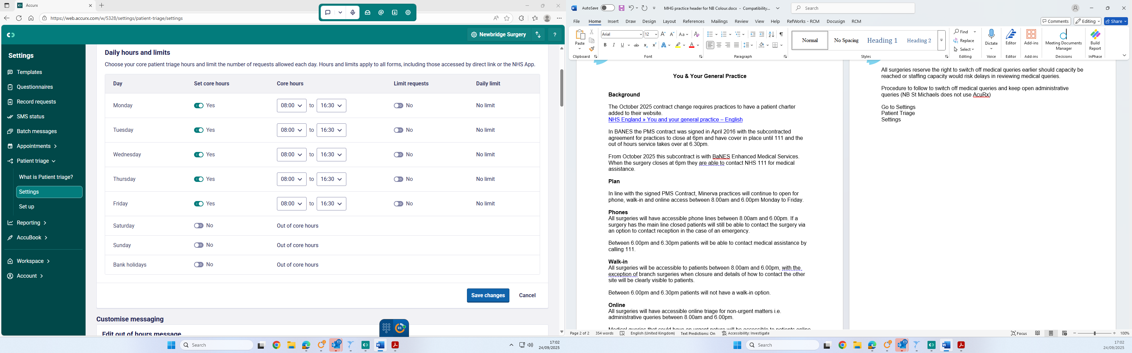

Set Daily Hours and limits

8.00am to 6.00pm

At the agreed time it is the responsibility of the Triage GP to switch off medical requests but leave open admin requests.

In settings, scroll down to Temporarily suspend Patient Triage Access

Switch on and tick Suspend medical requests only

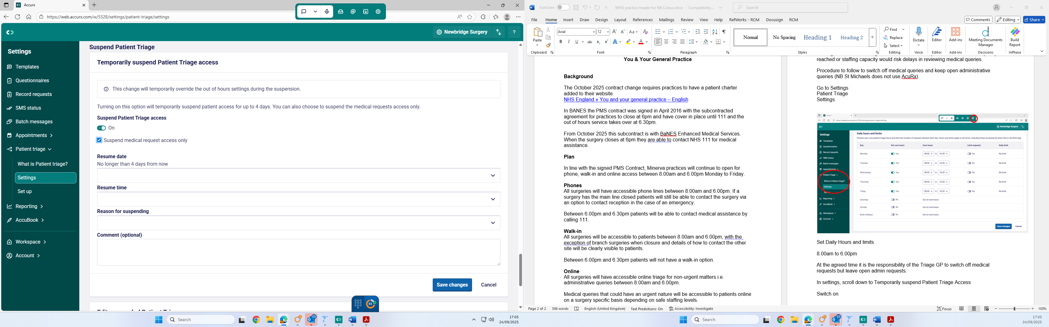

Ensure date and time set for triage to resume the following morning at 8.00am.

Select reason as Other (unless suspending early due to overwhelm).

The suspend Patient Triage message will need to be amended to state:

We have paused access to contact us medically online as we have reached capacity for the day. If it is urgent for today, please call 01225 446087 instead, but if we have reached capacity, you will be directed to 11. if it routine please complete a form when the service re-opens at 8am tomorrow.

Patients will not be informed at this point that admin queries remain open in case this encourages contact regarding medical queries in the admin form which would create risk for patients.

